FPGArcade

Nicholas Burek
Nicholas.Burek@loras.edu

Thomas Griebel
Thomas.Griebel@loras.edu

Submitted for the 2011 Digilent Design Contest

At Rose-Hulman Institute of Technology in Terre Haute, Indiana

May 1st, 2011

Advisor: Dr. Danial Neebel

Loras College
Dubuque, Iowa, USA
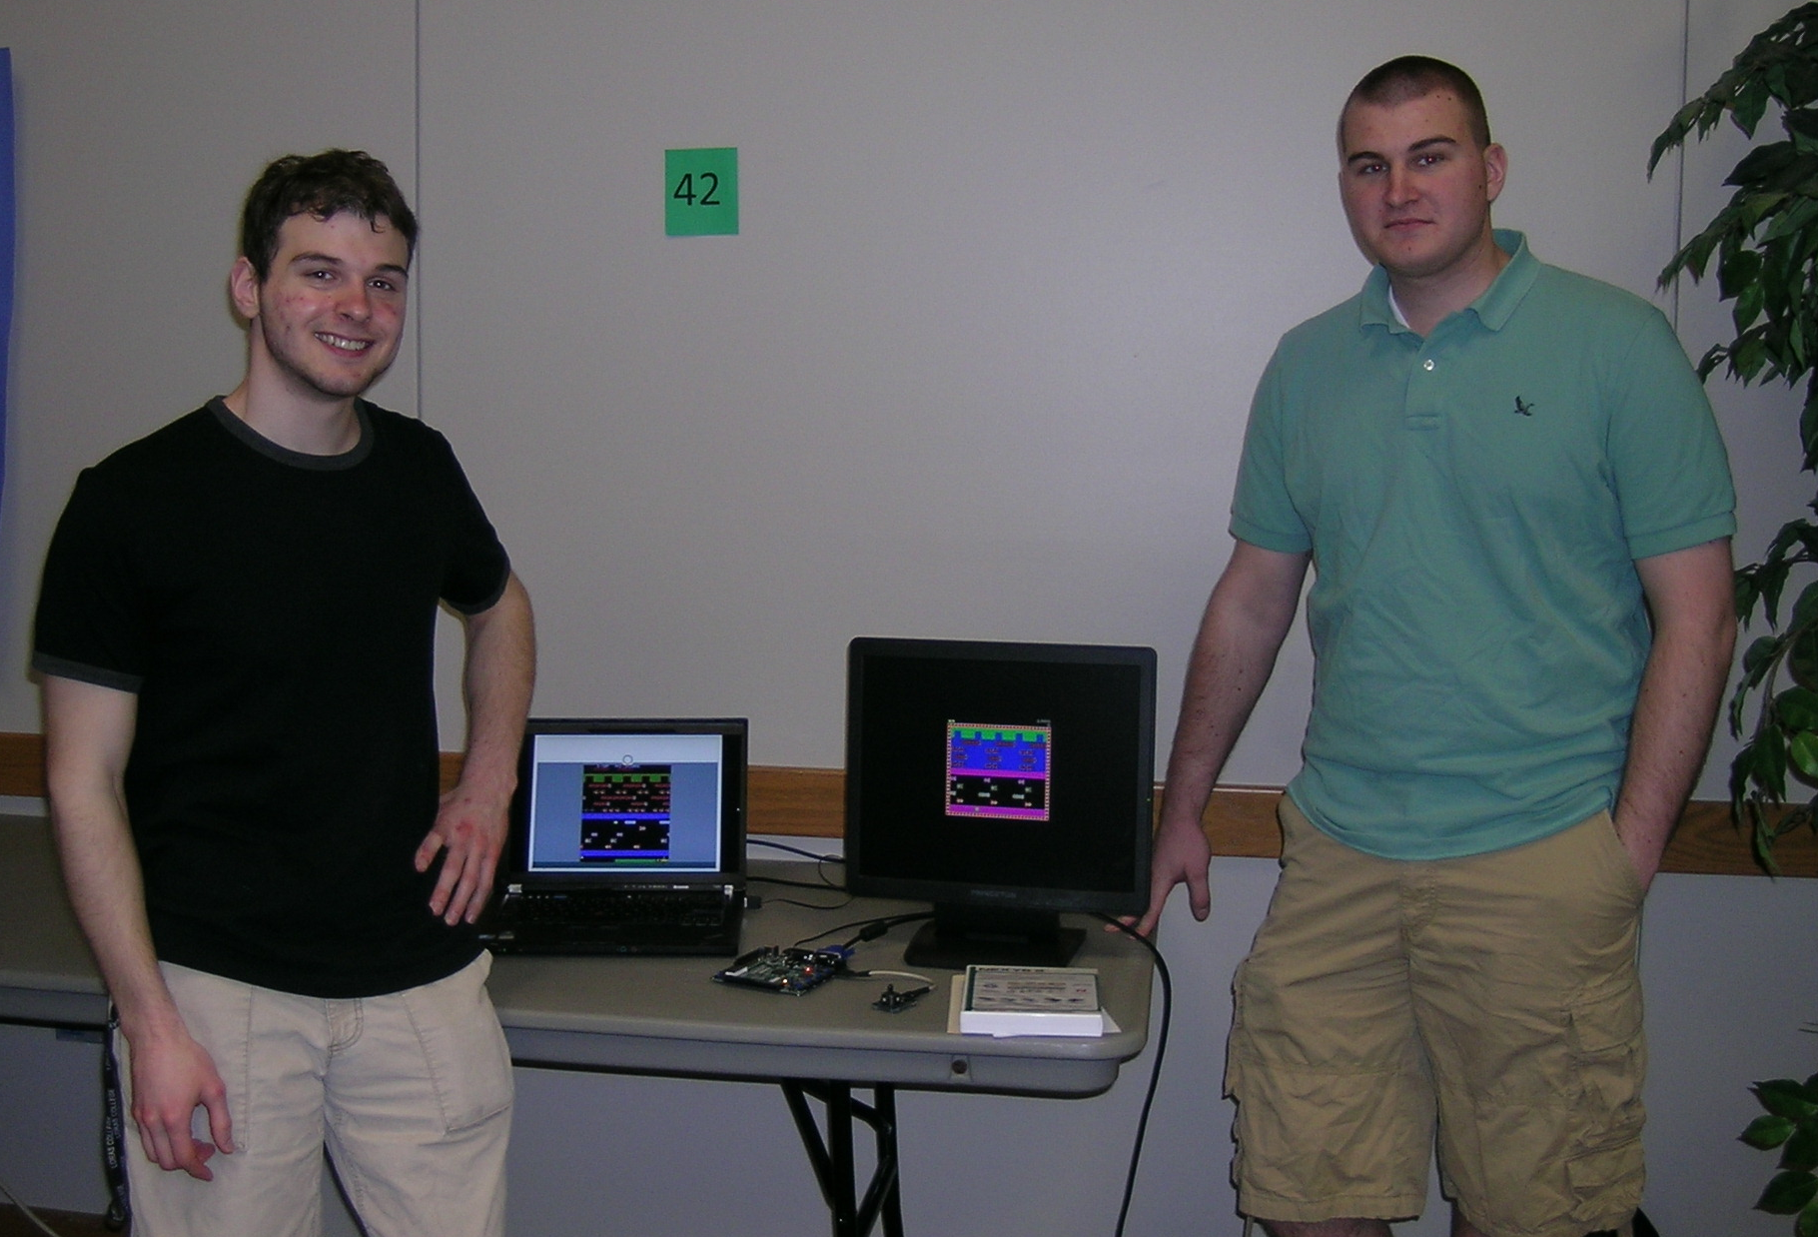

{Your “Product Marketing Sheet” Goes Here}

Introduction

Abstract
Uses a Nexys2 board with PModJSTK’s to create a programmable arcade system, which we then used to implement the classic 1982 game Frogger and the 1972 game Pong.

Objectives

The goal of this project was to create an easily programmable arcade system for anyone looking to create an arcade game on the Nexys2 platform.

Features-in-Brief

The project requires four main pieces of hardware. The first piece is the joystick driver which handles the SPI interface with the PModJoystick devices. The second piece is the video memory controller which handles the BRAM interface and fetching the appropriate pixel data that you want to display. The third piece of hardware is the VGA driver which handles all of the sync timing signals required to drive the connected VGA monitor. It also communicates with the video memory in order to pull the pixel data that it needs to display. These first three pieces of hardware are all implemented as VHDL IP in the project. The fourth piece of hardware in the project is the Microblaze processor core system, including all of its buses, instruction RAM, data RAM, etc. The Microblaze processor core uses two GPIO’s to communicate with the joystick driver and the VGA driver in order to send and receive data from them.

Project Summary

Our project seeks to create an easily programmable arcade system on the Nexys2 board. It uses the VGA port for displaying the games and uses two PMod joysticks as controllers for the system. All game logic is implemented in C code, running on the embedded Microblaze core. The arcade system uses a tile based graphics engine based off the Nintendo Picture Processing Unit that was used in the Nintendo Entertainment System. This allows for repeating patterns to be stored only once, thus reducing memory consumption. These tiles can be easily changed via the software by using our included graphics library. Because the graphics and joystick controllers are implemented in a modular way, you can easily create different style games without the need to change any of the hardware implementations. Using this system we have recreated two classic arcade games, Pong and Frogger.

Digilent Products Required

- Nexys2-500 FPGA board
- (2 x) PModJSTK

Tools Required

- Xilinx EDK – For code development
- Digilent Adept – For uploading files to the Nexys2 board

Design Status

The project is about 95% complete. Due to time constraints, we were not able to get different games to load off of an SD card like we had originally planned.

In addition to implementing the SD card reader so we could load different games without reprogramming the board we had several other ideas for future project expansion:
- Implement a double buffer system in hardware
- Expand the number of available graphics tiles
- Create new games to run on the system
- Add speakers and create a sound library

Background

Why This Project?

When we heard about the Digilent contest we really wanted to join to get some hands on experience working with FPGA boards, however we were both pretty limited in our knowledge and experience of working with FPGA boards and hardware design. We decided to make an arcade system because we both had an interest in video game programming and thought it would provide a fun medium for learning about FPGA design. We then decided to create it with software settable graphics so that if someone wanted to create a different type of game they would be able to use our base hardware and only need to worry about the software side of the game.

Design

Features and Specifications

The Microblaze core uses memory mapped I/O along with a 32-bit instruction set that we defined in order to communicate with the VGA Driver. The VGA Driver uses these instructions to set pixel information and change block and tile data that is stored in the BRAM. This allows us to use the same hardware to create different games by having the software change the tile set.

The VGA Driver is constantly calculating which pixel data it needs to pull from memory, fetching that pixel data from memory, and outputting it to the screen. At the same time the joystick drivers are communicating with the PmodJSTK boards via SPI. The joystick drivers are also memory mapped to the Microblaze core so that it can easily read the data from the joysticks.

Design Overview
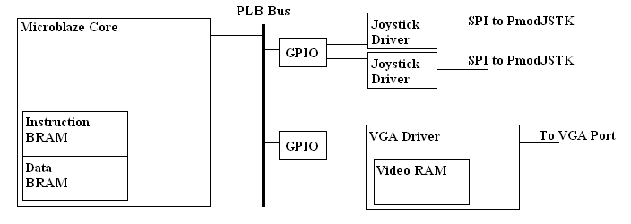
Detailed Design Description

The Microblaze core is setup to have 16KB worth of Instruction BRAM and Data BRAM. It uses two GPIO instances, connected to the PLB Bus, to do memory mapped I/O with the Joystick Drivers and VGA Driver. The GPIO reads 23 bits worth of data from each of the joysticks. It uses 10 bits of data for both the X and Y position of the joystick and 1 bit of data for each of the three buttons on the joystick. The GPIO associated with the VGA Driver is set to output 32 bits of data. We used a custom defined instruction set to allow the system to change data associated with the graphics. Below you can see the different instructions and what the different bits in the instruction are used for.
- Set Pixel
  - [7:0] – Color Value
  - [10:8] – X position of pixel in tile
  - [13:11] – Y position of pixel in tile
  - [19:14] – Tile Number
  - [31:29] – OP Instruction Number
- Set Moving Block Row Transparency
  - [3:0] – Row in moving block
  - [6:4] – Moveable Block number
  - [14:7] – Transparency Value
  - [31:29] – OP Instruction Number
- Set Moveable Block Location
  - [9:0] – X position on screen
  - [18:10] – Y position on screen
  - [22:19] – tile number
  - [31:29] – OP Instruction Number
- Set Moveable Block
  - [3:0] – Moveable Block Number
  - [9:4] – Tile Number
  - [31:29] – OP Instruction Number
- Set Background Block
  - [6:0] – X position of background block
  - [12:7] – Y position of background block
  - [18:13] – Tile Number
  - [31:29] – OP Instruction Number
The VGA Driver is also responsible for generating the sync signals for the VGA output and outputting the color data for the pixels. To do this it must track the x and y coordinate of which pixel it is currently trying to output. It passes that data to the Video RAM which then determines which tile it must output. It does this by first determining if there is a moveable block over top of the position it is currently trying to output if there is then it looks up which tile is associated with that moving block. If there is no moving block at that location it instead calculates which background black is at that position by bit shifting the X and Y position 3 bits to the right, the same as dividing the numbers by eight (the dimension of the block). It then looks up which of the tiles that background block is set to display. Once it knows which tile it needs display data from it will then determine which pixel from that tile needs to be displayed. If it is a background block this is a simple as taking the 3 lowest bits from the X and Y value. If it is a moveable block then it must take the X and Y positions and modulo it with 8 to determine which pixel we want. Once it knows which tile we want to use and which pixel it wants from that tile it converts that into a memory address and looks up the pixel data stored in that location. It passes that back to the VGA Driver, which then outputs that on the VGA red, green, and blue pins.

The joystick driver’s main responsibility is to constantly communicate with the PmodJSTK using Serial Peripheral Interface protocol. The PmodJSTK uses a 5 byte word to pass data. The entire first byte and the first 3 bits in the second byte store the X position of the joystick. The entire third byte and the first 3 bits in the fourth byte store the Y position of the joystick. The final byte contains the data for the buttons in the lower 3 bits. Each time it gets a full set of new data from PmodJSTK it outputs it to the memory mapped I/O pins, which the software can then read using the GPIO.

Included in our source code, there are two C libraries that we created to handle software/hardware interface. The first library was for the joysticks. It contains methods for fetching the data from both joysticks and storing it back into a data structure for the joystick. The second library is a graphics library. This library contains functions you can use output data to the Video RAM without needing to worry about constructing the 32-bit instruction and outputting it with the GPIO. It also contains functions to transform arrays of pixel data that are stored using our standard.

During the development of our Frogger game code we defined a standard for storing the graphics data of a single tile using an array of u32 variables. The standard uses 4 bit indexed color in order to fit 8 pixels worth of data into a single u32 variable. With an array of 8 u32 variables you can store a single 8x8 tile. When using this standard you first define your color array with at most 16 different colors. This would look like:
u8 carColors[10] = {BLACK,PURPLE,RED,YELLOW,GREY,GREEN,CYAN,PURPLE,BLUE,BROWN};
You would then need to create a u32 array such as this:
u32 tileGraphic[8];
To define how a row looks you use a hex format with 8 characters. Each character in the hex value represents the index of the color to use for that pixel. An example of setting the second row to display alternating red and blue pixels would look like:
tileGraphic[1] = 0x28282828;
The character furthest to the left defines the left most pixel in the row and the pixel furthest to the right defines the right most pixel in the tile. Once you have defined all the rows in your tile you can use the mapArrayToTile() function to output the graphics data to a tile in hardware. If you’re graphics are less complicated it may be easier to use the setPixel() function directly to change individual pixels in the tile.

Discussion

Problems Encountered

The first major issue that we encountered when working on the project was the way in which we wanted to store the video data. It was our original plan to store a distinct value for every single pixel in the 640x480 display. Doing this however would require far too much memory to fit in the block RAM, which means we would need to store all the data in the Mircon RAM chip on the board. However this would not allow us to have fast enough read/write times without implementing buffers to store data in. To avoid this problem and keep the system simple we decided to use a tile based graphics system instead, which would allow us to store repeating patterns in our 64 different tiles and then just set different sections of the screen to display what was in those tiles. This drastically reduced the amount of memory that we needed and allowed us to store it all in the onboard BRAM.

The other major problem we encountered was that our code for the Frogger game became too large to fit into the instruction memory that Microblaze had allocated. Since we could not allocate more that 16KB of memory for Microblaze we had to restructure large portions of our project to use less memory. By restructuring the way our graphics were output in software and by setting the compiler to optimize for size we were able fit the rest of the code within 16KB.

References

- Nexys2_500General UCF File
- Nexys2 Reference Manual
- Nexys2 Schematic
- Digilent_Nexys_EDK_Board_Support_Files
- PmodJSTK Reference Manual
- VGA Reference Component

Appendix A: VGA_Module Files

block_graphics_bram.vhd – Construct for the BRAM that holds the data for the background and moveable blocks.

tile_graphics_bram.vhdl – Construct for the BRAM that holds the pixel data for the 64 different tiles.

Video_Ram.vhd – Handles the BRAM interface to store all the tile and block data. Handles the fetching of pixel data when the x and y coordinates change for the VGA outpt.

clk25Mhz.vhd – Converts a 50Mhz clock signal to a 25Mhz clock signal.

VGA_Module.vhd – Handles the sync signals and output signals for the VGA monitor.

Appendix B: PmodJSTK Module Files

clock50Khz.vhd – Converts a 50Mhz clock signal to a 50Khz clock signal.

PmodJSTK_Driver – Handles the Serial Peripheral Interface communication with the PmodJSTK devices.

Appendix C: Hardware Interface Files

graphicsLibrary.h
graphicsLibrary.c – Provides functions for output pixel data to tiles and setting block data. Also includes several functions for transforming the graphics data that is stored in hardware, such as flipping and rotating tiles.

joystickLibrary.h
joystickLibrary.c – Provides a structure for storing joystick data and a function to fetch the joystick data and put it into that structure.

Appendix D: Pong Project Files

Pong.c – Provides all the game logic for the game Pong. Contains the main() function.

Appendix E: Frogger Project Files

Frogger.c – Contains the main() function. Contains the main program and game loops. Handles all the timing for object movement.

output_tileset.h
output_tileset.c – Contains code to output all the background tile graphics and output the background.

enemies.h
enemies.c – Contains the code to output all the moving object graphics as well as all the code to move the different objects and redraw them on the screen.

frog.h
frog.c – Contains the code to output the frog graphics, move the frog around, and a structure to store the frog’s data.

